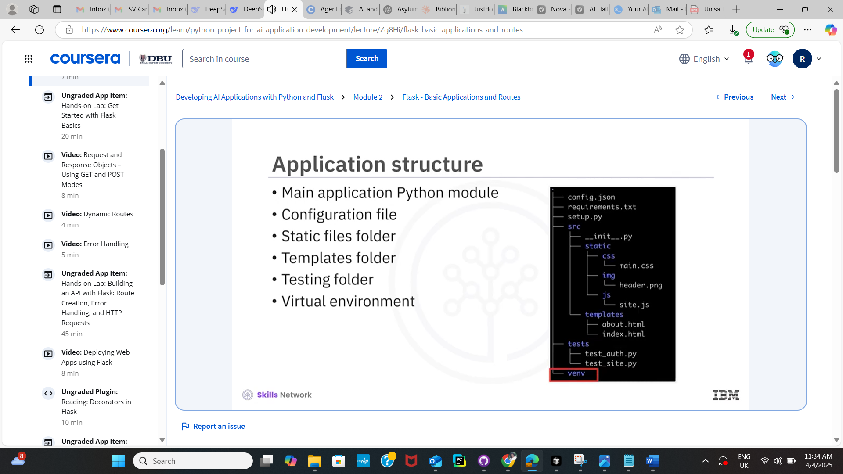 I've developed a comprehensive backend for the USA immigration system as requested. Let me explain what I've built:
Core Components
- SQL-Alchemy ORM Models:
  - Applicant: For storing personal information of applicants
  - Application: Tracks application processing from submission to decision
  - Document: Manages uploaded documents with verification status
  - Permit: Handles issued permits with expiration tracking
  - User: For authentication with role-based permissions
- Service Layer Components:
  - ApplicantService: Manages applicant data and status changes
  - ApplicationService: Processes applications through the workflow
  - PermitService: Handles permit creation, activation, and expiration tracking
  - AuthService: Manages user authentication and token generation
- Permit Tracking and Expiration System:
  - Functions to identify permits expiring soon
  - Status updates for expired permits
  - Email notification system for imminent expirations
- Authentication and Authorization:
  - JWT-based authentication system
  - Role-based access control (Admin, Officer, Supervisor, Applicant)
  - Password hashing and verification
  - Token generation and validation
- Error Handling and Logging:
  - Custom exception classes for different error types
  - Comprehensive logging with rotating file logs
  - Structured error responses
- Utility Functions:
  - Date manipulation and validation
  - Email validation
  - Password strength checking
  - Input sanitization
  - Email notification formatting
- Unit Tests:
  - Test fixtures for database setup
  - Tests for applicant service functionality
  - Tests for permit service and expiration handling
  - Tests for authentication system
The system is designed to be modular, secure, and follows best practices for Python backend development. Would you like me to explain any specific component in more detail or make any adjustments to the implementation?

